File permissions in Linux

Project description
This project focuses on understanding and managing file and directory permissions in a Linux system. It covers how to view detailed permission information using the ls -la command and explains the structure of permission strings. The project also demonstrates modifying permissions for files, hidden files, and directories to control user access.

Check file and directory details
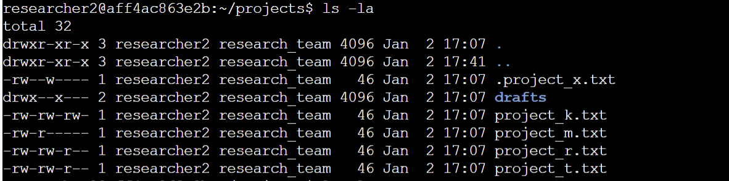
To check the permissions set for files and subdirectories in a directory (including hidden files), the command ls -la is executed.
Describe the permissions string


The 1st character (d) of the above 10-character string denotes it as a directory (a – represents a file)
The 2nd, 3rd, and 4th characters represent the permissions for users, with r representing read, w representing write, and x representing execute permissions.
The 5th, 6th, and 7th characters represent the permissions for groups, with r representing read, - representing no write, and x representing execute permissions.
The 8th, 9th, and 10th characters represent the permissions for others, with r representing read, - representing no write, and x representing execute permissions.

Change file permissions
The command chmod o-w project_k.txt is executed to revoke write permission from others of project_k.txt
- chmod changes file permissions
- o-w revokes write permissions from others
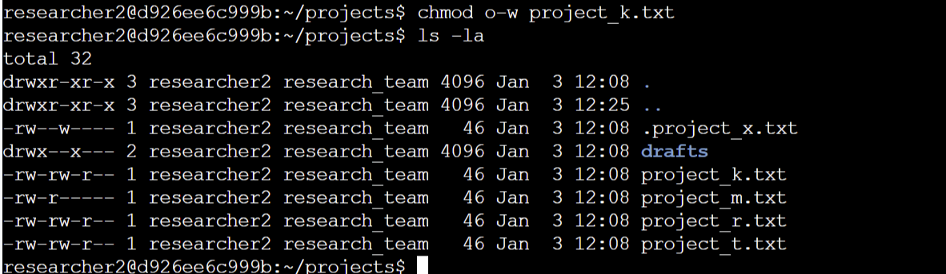
- project_k.txt denotes the file whose permissions are being modified

Change file permissions on a hidden file
The command chmod u-w, g+r-w .project_x.txt is executed to revoke write permission from users and groups, and give read permissions to groups of the hidden file project_x.txt
- chmod changes file permissions
- u-w revokes write permissions from users
- , indicates that the permissions for a next accessor is being modified
- g+r-w adds read permissions and revokes write permissions for groups
- .project_x.txt denotes the hidden file whose permissions are being modified
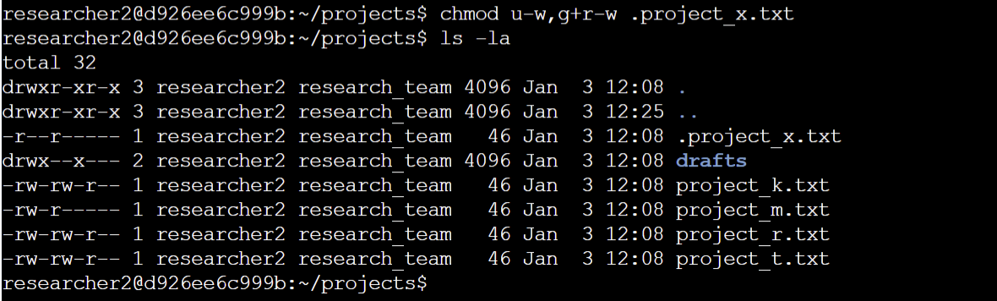

Change directory permissions
The command chmod g-x drafts is executed to revoke execute permission from groups, ensuring that only researcher2 can access the drafts directory and its contents
- chmod changes file permissions
- g-x revokes execute permissions from groups
- drafts denotes the subdirectory whose permissions are being modified
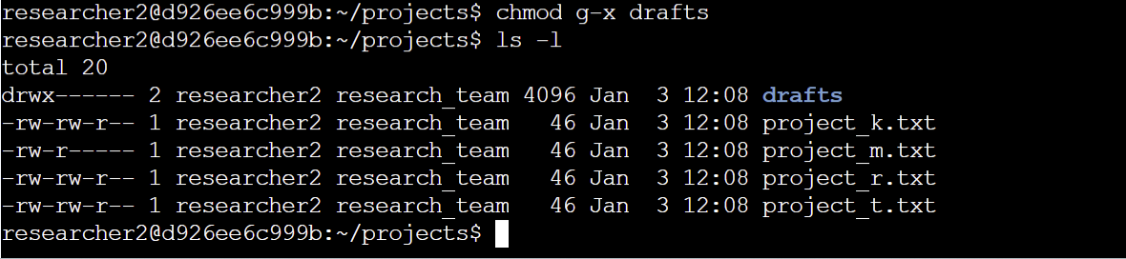

Summary
In this project, file and directory permissions were checked using the ls -la command, including hidden files. The permission string was analysed to understand how access rights are assigned to users, groups, and others. File permissions were modified by revoking and granting read, write, and execute permissions for regular files, hidden files, and directories using the chmod command. These tasks demonstrated how Linux permissions are used to control access and improve system security.

